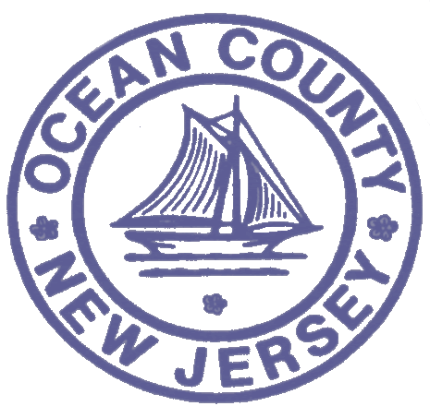

FOR IMMEDIATE RELEASE:
DATE: 12/03/18

Contact: Brian E. Rumpf
Director of Administration and
Program Development
732-341-9700 ext. 7210
OCEAN COUNTY HEALTH DEPARTMENT
P.O. Box 2191
Toms River, NJ 08754-2191

PRESS RELEASE

________________________________________________________________________________________________________
MEASLES update * as of DECEMBER 3, 2018 * 4:30 P.m.

The following is a summary with new and ongoing information with respect to the measles outbreak from the Ocean County Health Department.
- There are now 18 confirmed measles cases.
- There are also 7 potential cases under investigation.
- The measles outbreak is presently defined by a rash onset date of October 17, 2018 through November 24, 2018.
- Vaccination is encouraged and those children involved with exposure to a confirmed case may be subject to an order of exclusion, if unvaccinated.
- The Ocean County Health Department continues to support and highly encourage the exclusion of non-vaccinated children from schools, preschools and daycares in the outbreak area. These entities have the authority to make that decision when an outbreak has been declared by the New Jersey Department of Health. The age range so far for the current outbreak is 6 months to 59 years old.
- People are reminded to check their immunization records and if there is any sign of symptoms to contact your healthcare provider prior to showing up at that provider’s office so that appropriate arrangements can be made for examination or treatment.
- The potential for spreading infection exists four days prior and four days after a measles rash onset.
- People can become ill from measles from 5 to 21 days after being exposed to the virus.
- Measles-like symptoms include fever, rash, runny nose, cough, loss of appetite and pink eye.
- Measles can spread through coughing and sneezing and can live on surfaces and in the air for up to two hours.
- 30% of measles cases involve additional serious health complications.
- The Ocean County Health Department continues to communicate and coordinate daily with the State of New Jersey Department of Health and other healthcare providers in response to the measles outbreak.

To obtain additional information, please visit our website at the Ocean County Health Department’s website at www.ochd.org. Also, please check out our new website at www.phu2.org, to access and learn more about our Public Health is You Too! campaign to help equip you to take simple steps to improve your health.

XXX

