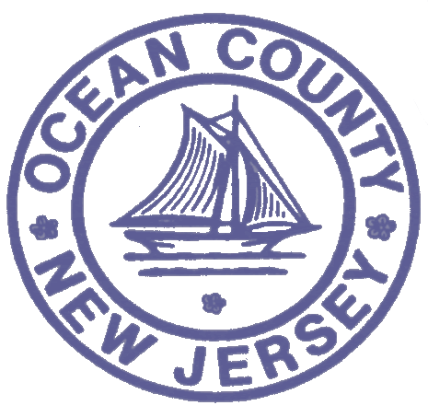

FOR IMMEDIATE RELEASE:
DATE: 12/07/18

Contact: Brian E. Rumpf
Director of Administration and
Program Development
732-341-9700 ext. 7210
OCEAN COUNTY HEALTH DEPARTMENT
P.O. Box 2191
Toms River, NJ 08754-2191

PRESS RELEASE

________________________________________________________________________________________________________

MEASLES update * DECEMBER 7, 2018

Eighty-six Ocean County residents recently attended an invitation only event where measles exposure may have occurred. The Ocean County Health Department is endeavoring to contact all of the potentially exposed persons and others in its continued investigation and efforts in support of containing the measles outbreak. Each Monday, Wednesday and Friday the Ocean County Health Department conducts a detailed conference call with the State Department of Health to review existing or potential measles cases and information and data regarding laboratory analysis and vaccine distribution. Ocean County Health Department epidemiologists continue to work with their State counterparts to identify sources of exposure and multiple contacts continue to be made throughout the community to investigate, educate and warn potentially exposed persons.
While Ocean County’s confirmed measles cases remain at 18, with 6 remaining under investigation, Ocean County Health Department Public Health Coordinator Daniel E. Regenye, cautions that the measles outbreak is likely far from being over. “While it is understandable that many would like to file this outbreak into the history books, we must continue to be vigilant and to take all necessary precautions to avoid an escalation of this measles outbreak.” “The unchanged number of confirmed cases demonstrates the effectiveness of public health measures already put into place and we are grateful for the efforts of community leaders and members of the public who have embraced and amplified the messaging from the Ocean County Health Department.” “Our message now is to remain informed on the status of potential measles exposure, insure that one’s family is fully vaccinated and protected, and encourage others in the community to do likewise as we work towards the eventual eradication of measles in our County,” concluded Regenye.
Attached as a reference is a prior release detailing some of the efforts of the Ocean County Health Department in combating the measles outbreak. To obtain additional information, please visit our website at the Ocean County Health Department’s website at www.ochd.org. Also, please check out our new website at www.phu2.org, to access and learn more about our Public Health is You Too! campaign to help equip you to take simple steps to improve your health.

XXX

