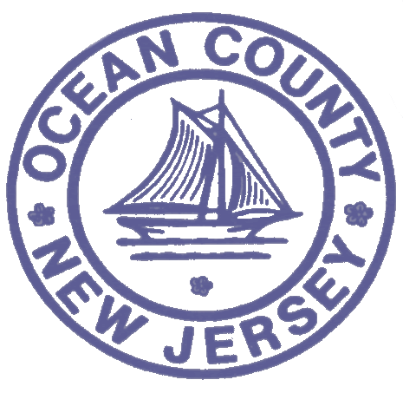

FOR IMMEDIATE RELEASE:
DATE: 12/14/18

Contact: Brian E. Rumpf
Director of Administration and
Program Development
732-341-9700 ext. 7210
OCEAN COUNTY HEALTH DEPARTMENT
P.O. Box 2191
Toms River, NJ 08754-2191

PRESS RELEASE

________________________________________________________________________________________________________

MEASLES update * DECEMBER 14, 2018

Ocean County’s confirmed measles cases now are at 19, with 1 remaining under investigation. Ocean County Health Department Public Health Coordinator Daniel E. Regenye, cautions that the measles outbreak continues to generate reports of new potential exposure which must be immediately and thoroughly investigated. We must continue to be vigilant and to take all necessary precautions to avoid an escalation of this measles outbreak, and remind all medical personnel that measles is an immediately reportable disease.” We remain grateful for the efforts of community leaders and members of the public who have embraced and amplified the messaging from the Ocean County Health Department to limit any exponential worsening of this outbreak.” “Our message now is to remain informed on the status of potential measles exposure, insure that one’s family is fully vaccinated and protected, and encourage others in the community to do likewise as we work towards the eventual eradication of measles in our County,” restated Regenye.
Attached as a reference is the release of December 12th detailing some of the precautions recommended by of the Ocean County Health Department in combating the measles outbreak. To obtain additional information, please visit our website at the Ocean County Health Department’s website at www.ochd.org. Also, please check out our new website at www.phu2.org, to access and learn more about our Public Health is You Too! campaign to help equip you to take simple steps to improve your health.

XXX

